ROBMS Physical Education Grading and Expectations

Students must have proper footwear to participate in moving activities and portions of class. Teachers will create alternatives to participation depending on footwear situations examples include score keeper, refereeing, and stat keeper. No sanuks, crocs, boots, heels, or slides.

What is good character in a person?

In general, people who are considered to have good character often have traits like integrity, honesty, courage, loyalty, fortitude, and other important virtues that promote good behavior. ... Furthermore, a person with good character does the right thing because they believe it is the right thing to do.

Classroom Rules- 3 strike rule.
How does the 3 strike rule work with warnings?
Basically, a strike is a verbal warning for bad behavior. Every day, each child is allowed three strikes, or three verbal warnings before they lose a privilege. Yup, just like in baseball. After 3 strikes the student will be asked to sit out the remainder of activity!

The 13 Principles of PE
- Ask questions
- Respect and listen to your teacher and classmates
- Be prepared for class and follow the dress code
- Keep your hands to yourself and respect others’ property
- Be kind, use positive language, and have a good attitude
- Always do your best
- Be on time
- Use equipment properly
- Be respectful of others’ ideas
- Follow the teacher’s directions the first time they are given
- Cooperate with your classmates
- Use technology appropriately
- Be proud of your work and become a Leader
In this class we embrace and encourage a Growth Mindset and support each other in our goal to learn and constantly improve!
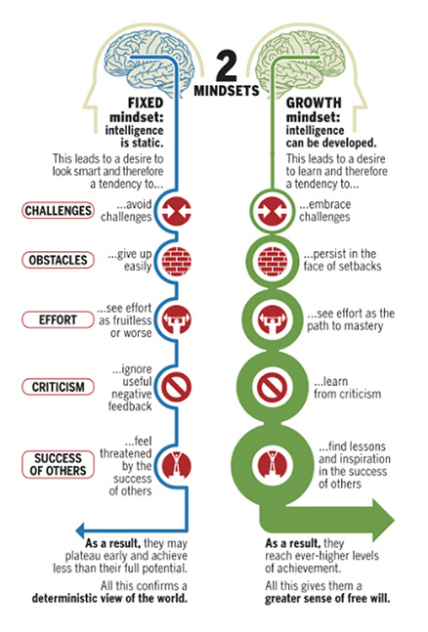

Grading

Majors= 50%
Activity test, skill assessment, google classroom check,

Minors= 30 %
Activity quizzes, personal goal sheets, fitness assessments,skill assessments.

Participation- 20 %
6pts per class

NW= -2 No Warm-up- Students did not complete the daily routine. Correctly sitting in designated squad, performing stretches to students best ability, and giving best effort during fitness ( exercises have modification for fitness levels).

HP= -2 Half Participation- Student was not following skill directions, game play rules, or sat out during activity.

NP= -4 No participation- Students failure to follow skill directions, game play rules, or sit out during the entire period.

Above grading will be combined based on students' performance in class.

Examples-

NWHP= -4

NWNP= -6

